No Place Like Home

Cassandra Hatcher

Introduction

The final frontier. Outer space. We have put man on the moon, rovers on Mars, and when New Horizons made it to Pluto we have officially flown by every planet in our solar system. But we are not stopping there. Mankind is on the quest to determine if we are in fact the only ones here. The search for extraterrestrial life is the newest race in astrophysics research. But before we can find if there is life on other planets we must narrow down our options and determine if the planet is even habitable. This article discusses a very generalized process for determining the habitability of a planet.

Background

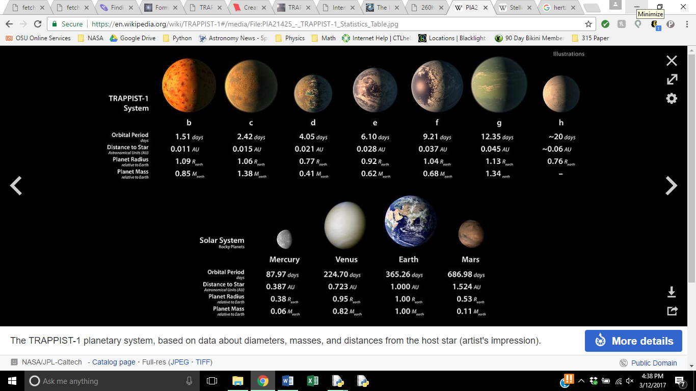NASA has many missions that are searching for exoplanets (what’s an exoplanet?). Kepler, K2, the Spitzer Space Telescope, as well as future missions such as WFirst and the James Webb Space Telescope. Most recently on February twenty second NASA announced that their Spitzer Space Telescope just confirmed seven Earth sized planets within the Habitable zone of a star name Trappist-1. Below is a comparison of the Trappist-1 system and our solar system.

So how did they find these planets? Many complex techniques are used to determine if a planet could support life. Stars can be modeled as black-body emitters which allows us to determine the intensity of a star and its surface temperature. Knowing a stras(spelling) intensity allows us to determine how far out its habitable zone is. But before we can analyze these planets we must know where to find them. The Milky Way galaxy is estimated to contain one hundred billion stars. It is not feasible in our life time to observe every star for the possibility of life on an orbiting planet. If we narrow our search to the most common type of star in the galaxy it is analogous to studying the most common planets in the galaxy (Triaud and Gillon).The most common stars in the galaxy are ultra-cool dwarf stars. These stars are in spectral class M. Looking at the Hertzsprung Russell Diagram we see that Red Dwarfs are main sequence stars will(with) very low surface temperatures and luminosities. Most of these stars are too dim to be seen with the naked eye.

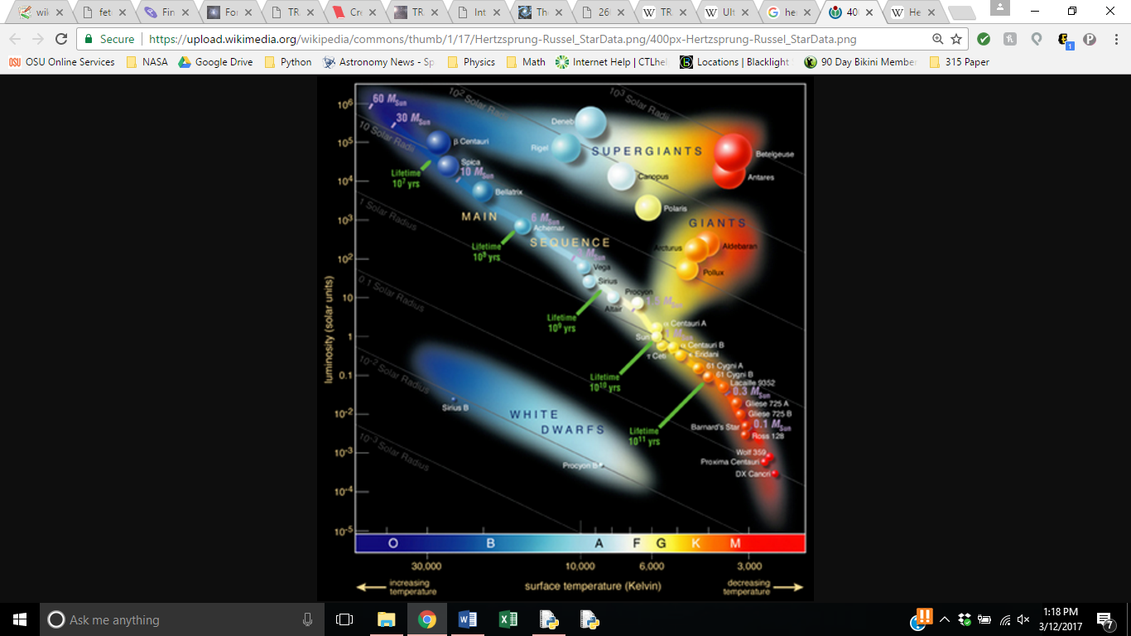

Image 2: (Hertzsprung-Russell Diagram)

Like our Sun a star can have planets orbiting that do not contain life. This means we first must narrow down our observations to locations that have the possibility of supporting life on a planet. This is what is called the habitable zone, the zone around a star that has the right combination of radiation and therefore temperature to support life. We know that liquid water means there is a very high chance of life.

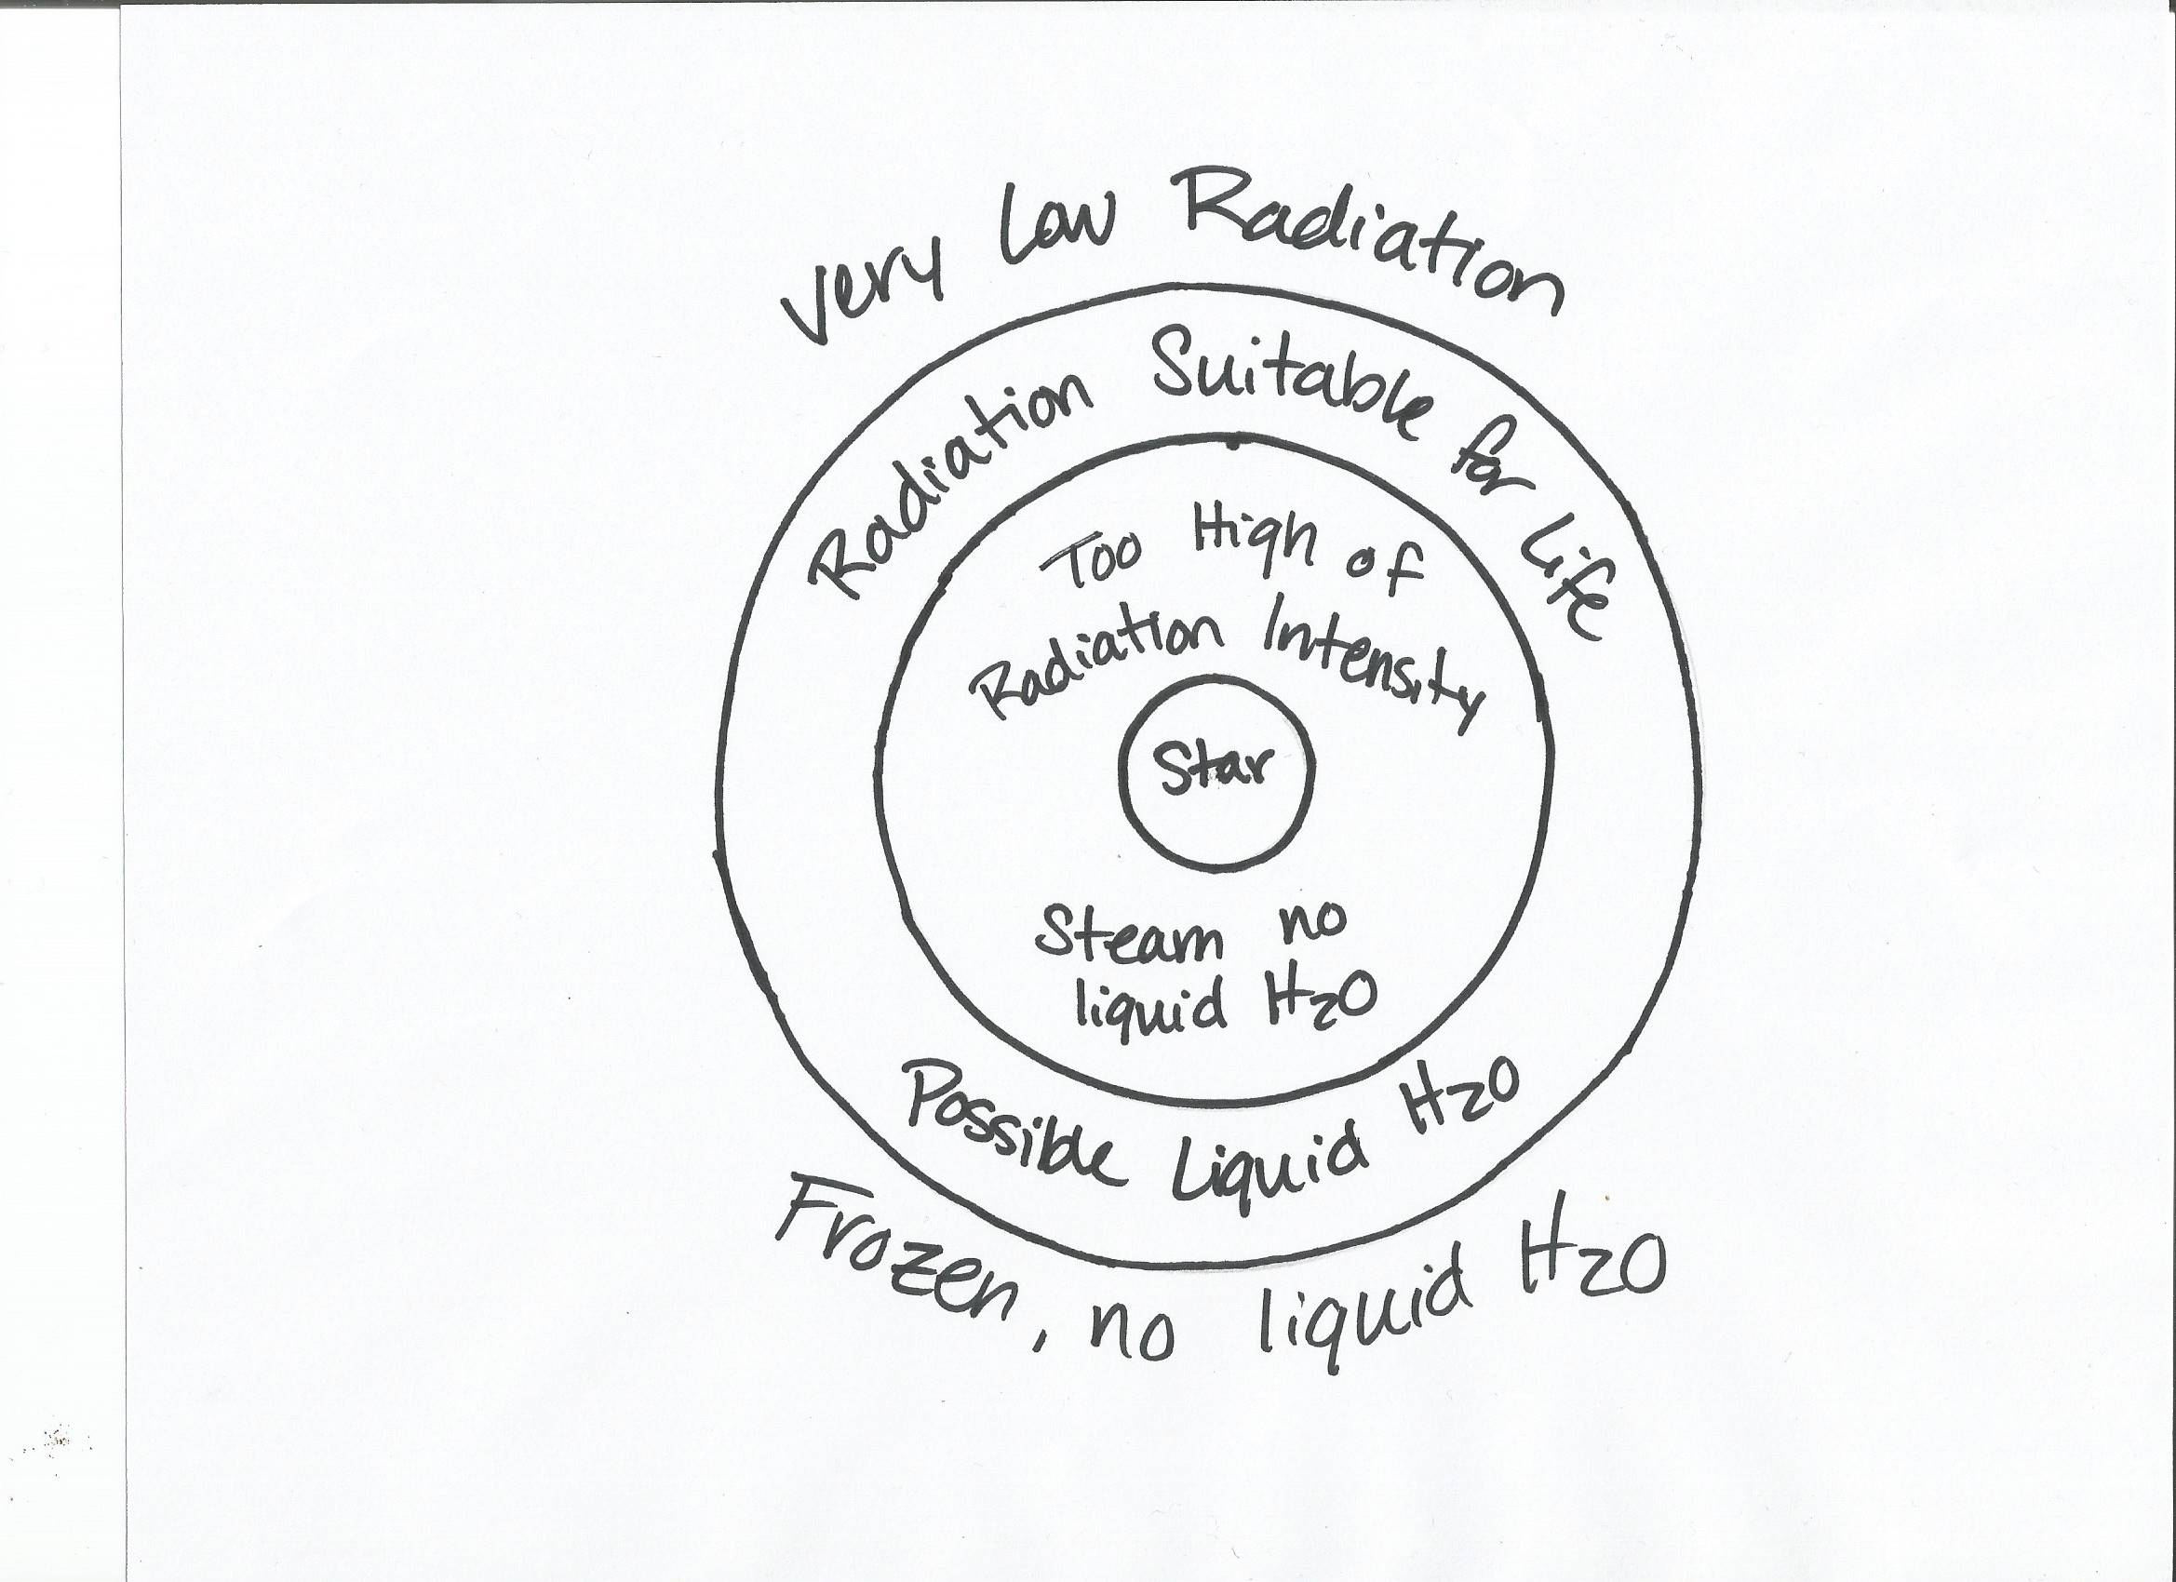

Due to the inverse square law, the intensity of a source decreases at a one over the square of the distance away from the source.(because intensity is like a surface area right?) That is why life can survive on Earth but not one(on) Venus as the radiation and temperature are too high, among many other reasons.

Body

Throughout this article we will be making calculations to determine the habitable zone around the star Trappist-1, as there is much information on the star to compare our results to. First we want to determine the luminosity of a star, which one can determine by comparing it to the luminosity of a known star. This is too complex of a calculation to explore in this article so we will use the known value of Trappist-1.

Trappist -1’s luminosity = 0.000525 Lo

Lo = one solar luminosity = 3.846x1026W.

LT = 2.02x1023W.

(Triaud and Gillon) (You might want to explain why luminosity has units of Watts while intensity is Watts/m2. Is luminosity the same thing as power?)

Using this value, we can determine the intensity at the surface (of) Trappist-1. We can use the equation

LT = 4πd2IT  (1)

(2)

Here d is the distance from the star to the location where intensity is being measured. If we want to know the intensity at the surface of Trappist-1, and d would be equal to the radius of Trappist-1.

LT = 2.02x1023W

d = 0.114 Ro where Ro is the radius of the Sun

d = 0.114(695.7x106 m) = 79,309,800 m

(Triaud and Gillon)

Comparing this to the intensity of the Sun, calculated using a property of Planck’s Law,

Is = σTs4 (isn’t this the Stefan-Boltzmann Law?)  (3)

Is = (5.7x10-8 W/m2K4)(5778K)4 = 6.353x107 W/m2

We can see that Trappist-1 produces less radiation that our Sun, we can assume that the habitable zone around Trappist-1 will be closer than the habitable zone of our Sun. Knowing the intensity of Trappist-1 will allow us to calculate the surface temperature of the star using the same relationship used to calculate the intensity of the Sun. The relationship we will use is Planck’s Law,

(4)

I is the intensity at the surface of the star, h is Planck’s constant, c is the speed of light, and kB­ is Boltzmann constant, and λ is the wavelength emitted by the star (Minot).

This relationship give us the black-body spectrum. A star behaves approximately like a blackbody (why only approximately?) and therefore emits thermal radiation in a continuous spectrum, per its temperature (Black-Body Radiation). One can determine the wavelength emitted by Trappist-1 and we have already found its intensity. The Black-Body Radiation diagram describes the relationship between wavelength, surface temperature, and intensity emitted know as Planck’s Law. Trappist-1 is an ultra-cool red dwarf star that released (releases) mainly wavelengths on the red end of the visible light spectrum (Glister). If we know the peak wavelength emitted by a star we can use the black body radiation diagram to find the intensity of the black body. I could not find wavelength of light emitted by Trappist-1 so I based my wavelength estimation of red light having a wavelength between 620 and 750 nanometers. Red dwarf stars often emit light on the far-red end of the spectrum so we will use 750 nanometer to make our estimation.

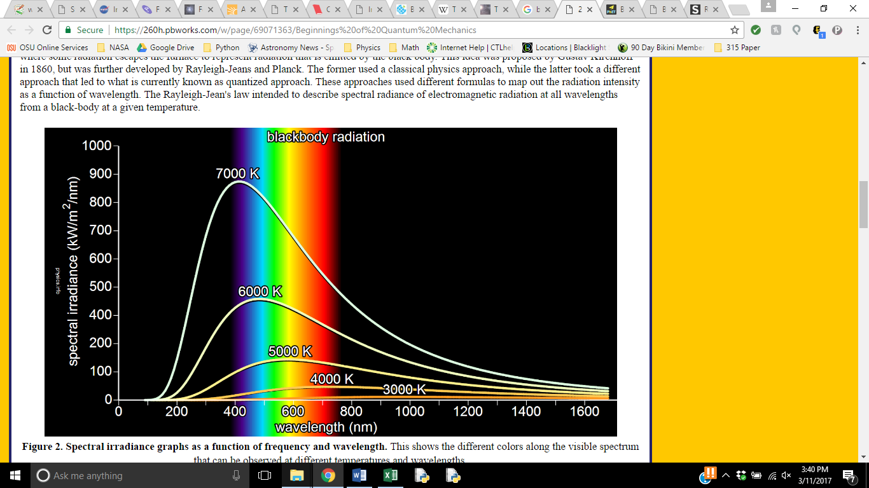

Image 2: (Hyperphysics)

Looking at this spectrum we can see that at 750 nanometers the maximum temperature a star could have would be 3000K. Rearranging Planck’s law to give us the relationship between the intensity and temperature we get the following (Minot)

I = σT4  (5)

Solving this equation for the temperature of Trappist-1 we find

(6)

It turns out that the actual temperature of Trappist -1 is around 2559 ± 50 K (Triaud and Gillon). Our calculated temperature of 2588K is perfectly in this range. Trappist -1 is much colder than our Sun which is 5778K so again we can predict that planets that could support life will be closer to Trappist -1 and Earth is to our Sun.

To determine how far out a star’s habitable zone is we can use the star’s radiation intensity and the radiation intensity that life can survive in. We know that life and(can) be sustained here on Earth so we can use the radiation intensity Earth receives with a range. It may be possible that life can be sustained in more or less radiation than what Earth receives. We can use the inverse square law to determine the radiation intensity received at the Earth (Minot).

(7)

Ir is the intensity received, Ps is the power released by the Sun, and r is the distance the Earth is from the Sun.

P= IASurface

Is = σTs4

r = 1.496x1011m

We can use this value to assume that the habitable zone around a star will be a radius at which a planet will received 1372 W/m2. I assume there will be a range of radiation values at which life can be sustained. On the surface of the Earth we do not receive the full radiation intensity due to our atmosphere. To sustain life a planet must have an atmosphere that can protect the planet from radiation needed to heat the planet to temperature suitable for life.(greenhouse effect) Mars receives less radiation than Earth, but Mar(s) does not have much of an atmosphere so the radiation at the surface of Mars is dangerous for life. For simplicity of calculations I will assume life can survive in ± 40% radiation that what is received here at Earth, assuming the atmosphere comparable (to) that of the Earth that will minimize this intensity by the time it reaches the surface of the planet.

This range will be 823.2 to 1920.8 W/m2 for future calculations. We want to know the radius at which a planet would receive these intensities around Trappist-1.

P=IA

Per this calculation the habitable zone around Trappist-1 is from 2.90x109 – 4.42x109 m. The data we have for the seven planets found around Trappist-1 states that these planets orbit at radius from 1.65x109 to 8.98x109 m (TRAPPIST-1). This range is much larger than our calculated range but our range is in the span of these orbital radiuses. Our calculations are not as near as complex as the calculations used to determine these planets are in the habitable zone. We did not account for the effect of atmospheres minimizing radiation by the time it reaches the surface, nor do we consider the magnetic field around a planet that detours radiation.(specifically gamma right?) Our calculations are reasonable enough to continue.

Knowing the intensity a planet receives allows us to calculate the surface temperature of the planet. We know that if there is liquid water there is a very high possibility of life. Water is liquid at 273 K. Due to planets spherical shape the temperature is not the same everywhere on its surface.(because the intensity of light is distributed unevenly over a sphere as opposed to a flat circular cross section right?)We can solve for a temperature of 273K knowing that even if it is hotter or colder than 273K at some points on a planet there is most likely some place on the planet where it is 273K.

If we assume that the planet has a similar atmosphere to that of the Earth it would most likely have an absorption rate comparable to that of the Earth which is 70%. This means the Earth reflects about 20% of incoming radiation. To determine the surface temperature of a planet we can look at the conservation of energy, the energy into a planet must be equal to the energy out of the planet.

Pin = Pout (8)

P=IAsurface

Iin π rplanet2* absorption = σT4planet Asurface planet

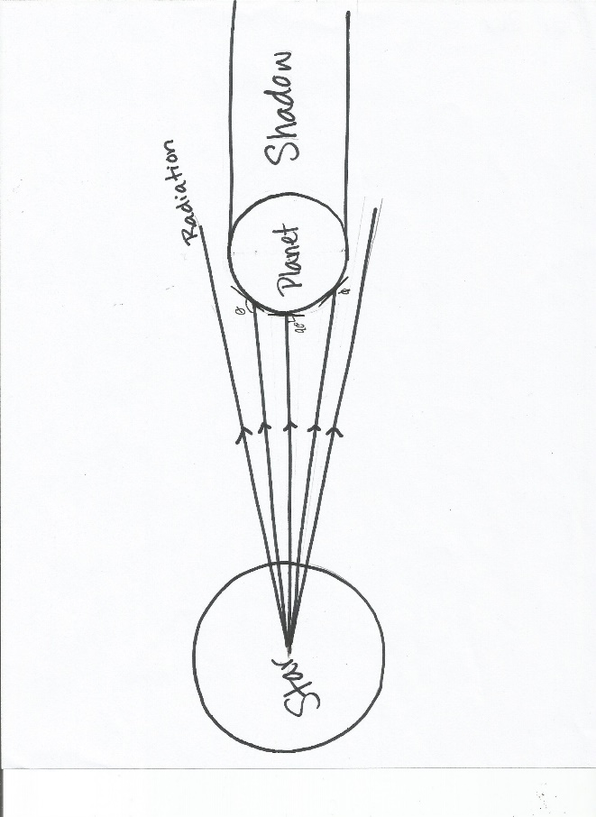Notice that on the left side of the equation we are not calculating a surface area for the intensity hitting the planet. This is since the star is radiating from one direction and does not hit the entire surface of the planet at the same time or at the same angle due to the curvature of the surface. (ignore my last comment…) The intensity hitting a surface at an angle is less that the intensity hitting the surface dead on. But a simple assumption solves this problem for the estimation purposes of our calculations (Minot).

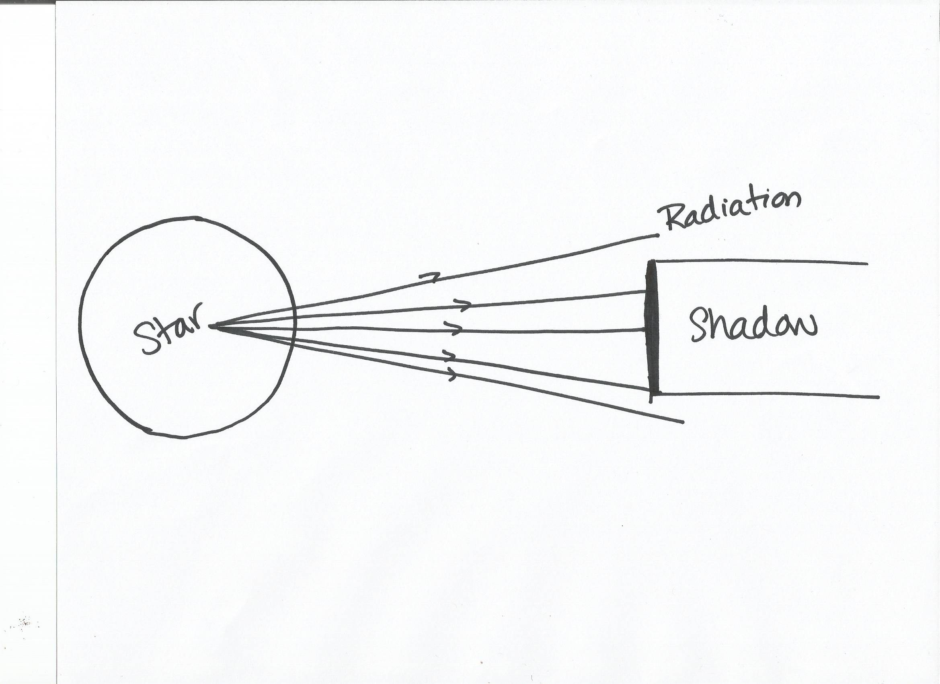

As seen in the diagram we can estimate the interaction surface to that of a cross sectional area of the planet. A flat circle of the same radius of the planet would absorb just as much radiation as a planet of the same radius.

Solving equation 5 for temperature we find that

(8)

At the edges of the range for the intensities previously calculated, we find that the temperatures possible for this zone are,

Tplanet =

Tplanet =

This give us a range of 225-277K for planets in the “habitable zone”. This range contains the temperature needed for liquid water. Although, our calculation assumes there is no atmosphere and therefore does not account for the insulation and green house affects an atmosphere provides. Even so it is a very good estimate to show that we should focus on the investigation of these planets.

Conclusion

From here the researchers would begin to use absorption and emission spectrums to identify the molecules in the planets’ atmospheres to determine if they could (sustain)inhabit life. Though the calculations in this article were just rough estimates(paul might get cranky if you say this and ask why you didn’t do better calculations… be careful if you admit this it might be safer to just omit this line), it shows a simplified process astrophysics, astrochemists, and astrobiologists,(don’t need last comma) must go through to determine if a planet is even worth studying for the hope of extraterrestrial life. Our calculations were all well within the range of the actual values so this process is very useful and quite accurate for its simplicity.

(try and put references on a separate page)

# References

"Blackbody Radiation - The Physics Hypertextbook." The Physics Hypertextbook. N.p., n.d. Web. 20 Sept. 2013

*Black-Body Radiation*. n.d. Las Cumbres Observartory. Web. 10 March 2017.

Calvin, Whitney and Michele Johnson. "In the Zone: How Scientists Search for Habitable Planets." *NASA* (2013). Web. 10 March 2017.

Chou, Felicia, Sean Potter and Elizabeth Landau. "NASA Telescope Reveals Largest Batch of Earth-Size Habitable-Zone Planets Around Single Star." *NASA* (2017). Web. 10 March 2017.

Glister, Paul. "TRAPPIST-1 : Three Nearby Worlds." *Centauri Dreams* 2 MAy 2016. Web. 10 March 2017.

Hertzsprung-Russell Diagram. Digital Image. *Wikiedia*. Wikimedia Foundation, 16 June 2017.

Web. 10 March 2017

The TRAPPIST-1 Planetary System. Digital Image. *Wikipedia.* Wikimedia Foundation, 22 February

2017. Web. 10 March 2017.

Minot, Ethon. *Class Notes Day 19*. 22 February 2017. PDF. 10 March 2017.

Triaud, Amaury and Michael Gillon. *About Trappist - 1*. n.d. Web. 10 March 2017.

*Visible Spectrum*. n.d. Wikipedia Foundation. Web. 10 March 2017.